OPTIFAST800
The serious solution for weight loss

The OPTIFAST program is designed to help obese people lose weight and significantly reduce weight-related health risks. It has been proven effective in over 80 clinical studies and by more than 1 million people who have participated in the program since 1974. It involves complete meal replacement with pre-packaged OPTIFAST supplements. This means no grocery store food or restaurant dining is allowed. Your daily caloric intake is either 800 or 960, depending on whether you have 5 or 6 supplements per day. It is a medically monitored program though, so you must be seen by one of our providers every two weeks. OPTIFAST can be used as the main method of weight loss, or it can be utilized to jumpstart one of our other weight loss programs.

Stimuli Narrowing Theory
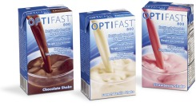
The theory behind OPTIFAST is that of “Stimuli Narrowing.” Research shows that the greater the variety and palatability of food in a given meal, the greater the caloric intake. As the variety decreases, so does the amount of calories consumed. The OPTIFAST program consists entirely of pre-portioned and calorie-controlled servings, so variety and quantity of food is limited.

Individualized Eating Plans
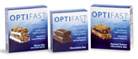
You and your medical provider will review your diagnostic tests, medical history, and the clinical necessity of using the OPTIFAST program. If decide upon the OPTIFAST program, you will have either five or six servings of OPTIFAST a day, preferably one serving every three hours you are awake. These servings consist of any daily combination of the single serving size OPTIFAST supplements. You may not skip any servings. Your provider might also discuss a partial OPTIFAST program, which replaces a supplement of OPTIFAST with a small meal. In addition, there are recipe books available for free, if you choose to experiment with the supplements.

Nutrition Protocol
OPTIFAST 800 Formula provides you with 100% of Recommended Daily Intake (RDI) for 24 vitamins and minerals. However, it is short on some electrolytes, including sodium, chloride, and potassium. To ensure that your electrolyte levels stay within the proper range, we will regularly take a blood sample and will require you to take a potassium supplement. In addition, a fiber supplement is recommended. We have the supplements available in the clinic, but you may also purchase them elsewhere. Lastly, you must drink at least 64 ounces of water daily while on the program.

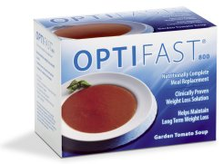
OPTIFAST Treatment provides clinically validated outcomes
- 52 lb average weight loss
- 15% average decrease in cholesterol
- 29% average decrease in blood sugar
- 10% average decrease in blood pressure

To hear patient testimonials, receive recipe ideas and help you stay motivated, please visit OPTIFAST.com

